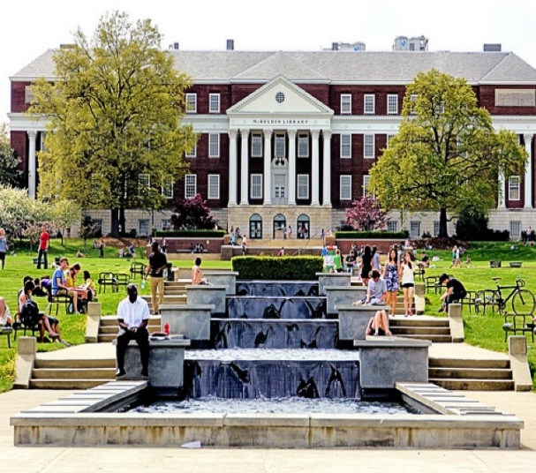
Call for Scholarship Applications!
NCCWSL (2026)
NCCWSL is the National Conference for College Women Student Leaders

AAUW invites students from around the world to an inspiring weekend for growth & networking.
For more information go to https://www.naspa.org/events/nccwsl

Held at the University of Maryland-College Park (just outside Washington, DC) May 27 – 30, 2026
AAUW-Wisconsin is offering five $1000 scholarships to cover registration, lodging and meals, and airfare.
Additionally, some AAUW branches may be offering scholarships.

For questions and to submit a scholarship application, please email Jan Eriksen, AAUW-WI Vice-President - Leadership
jperiksen@viterbo.edu

Deadline to apply for scholarship: April 1, 2026.
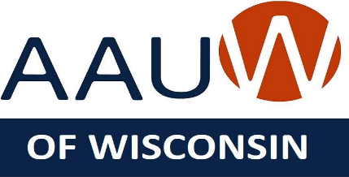
AAUW’s mission is to advance equity for women and girls through advocacy, education, and research.

